All of the dogs in the following photographs are American Staffordshire Terriers.

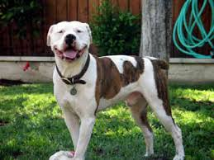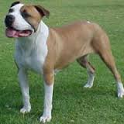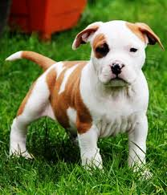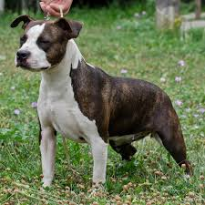

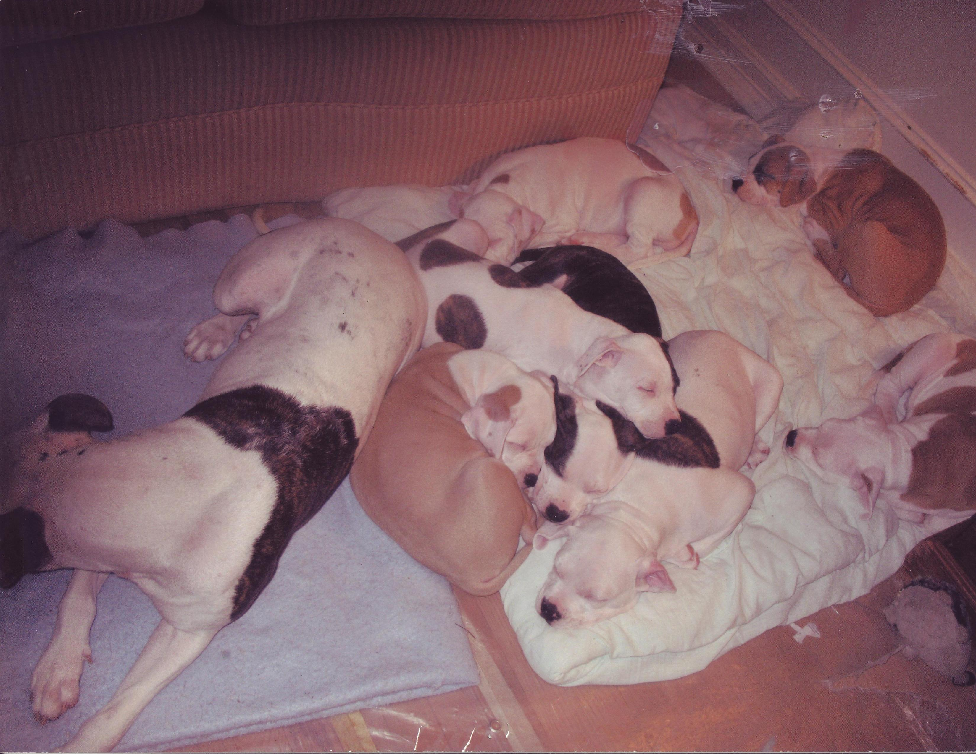

This is “Baby” our AmStaff with her litter. The American Staffordshire Terrier is recognized by the American Kennel Club and all universally recognized and accepted international kennel Clubs.

