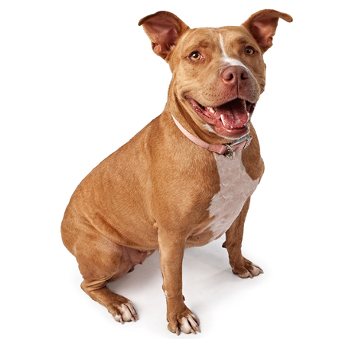 | American Pit Bull Terrier Information  BREED GROUP: Molossoids, Mastiffs, and Bulldog Breeds  WEIGHT: 35-60 lbs., in proportion to height  HEIGHT: 17-23 in.  APPEARANCE:  Nose: Black and self-colored according to coat.

Note that the best guess by the experts listed the weight of the commonly referred to English fighting “Pit Bull” dogs as 40 to 45 pounds and height as 14 to 16 inches: modern day versions are as much as 65 pounds and as tall as 24 inches.

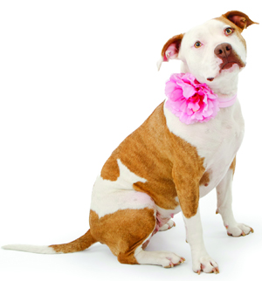 | American Staffordshire Terrier Information  BREED GROUP: Molossoids, Mastiffs, and Bulldog Breeds  WEIGHT: 35-60 lbs.in proportion to height.  HEIGHT: 16-19 in.  OTHER NAME(S): American Staffordshire Terrier; AmStaff; AST; American Pit Bull Terrier  APPEARANCE:  Nose: Black and self-colored according to coat.
AKC standards are: Nose definitely black. Size: Height and weight should be in proportion. A height of about 18 to 19 inches at shoulders for the male and 17 to 18 inches for the female is to be considered preferable.

