The Dogs | DNA Results | Survey Results
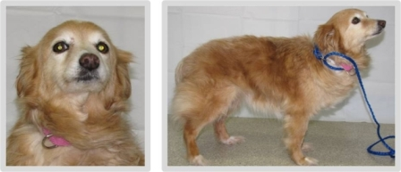 | Dog 01  - 25% Toy Fox Terrier  - 25% Harrier  - 15.33% Anatolian Shepherd  - 14% Chinese Crested | Top Responses  - Golden Retriever  - Pomeranian  - Shetland Sheepdog  - Cocker Spaniel  - Chihuahua
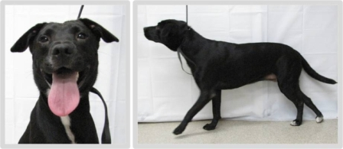 | Dog 02  - 50% Catahoula Leopard Dog  - 25% Siberian Husky  - 9.94% Briard  - 5.07 Airedale Terrier | Top Responses  - Labrador Retriever  - American Staffordshire Terrier  - No Predominant Breed  - Border Collie  - Pointer (includes English Pointer)
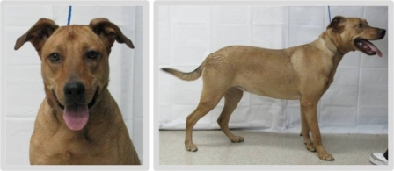 | Dog 03  - 25% American Staffordshire  - 25% German Shepherd  - 25% Lhasa Apso  - 25% Dandie Dinmont Terrier | Top Responses  - Labrador Retriever  - German Shepherd Dog  - Rhodesian Ridgeback  - No Predominant Breed  - American Staffordshire Terrier
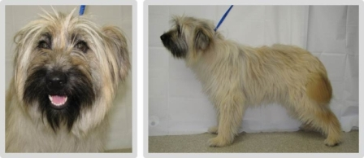 | Dog 04  - 25% Border Collie  - 25% Tibetan Spaniel  - 12.02% Catahoula Leopard Dog  - 9.28% Shiba Inu | Top Responses  - Wheaten Terrier, Soft Coated  - Bearded Collie  - Briard  - Cairn Terrier  - Tibetan Terrier
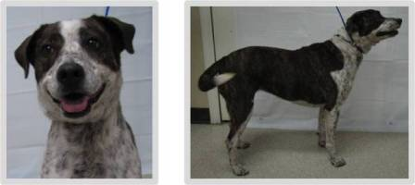 | Dog 05  - 25% Miniature Pinscher  - 25% Great Pyrenees  - 10.79% Afghan Hound  - 10.09% Nova Scotia Duck Tolling Retriever | Top Responses  - Australian Cattle Dog  - German Shorthaired Pointer  - Pointer (includes English Pointer)  - Border Collie  - No Predominant Breed
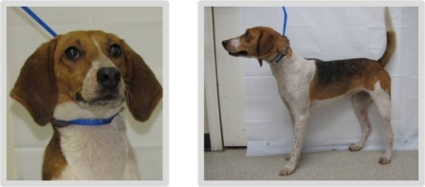 | Dog 06  - 50% American Foxhound  - 50% Beagle | Top Responses  - Beagle  - Foxhound (including American, English, Treeing Walker Coonhound)  - Harrier  - Black and Tan Coonhound  - Pointer (includes English Pointer)
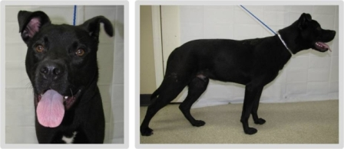 | Dog 07  - 25% Irish Water Spaniel  - 25% Siberian Husky  - 25% Boston Terrier  - 8.33% Bull Mastiff | Top Responses  - Labrador Retriever  - American Staffordshire Terrier  - No Predominant Breed  - German Shepherd Dog  - Staffordshire Bull Terrier
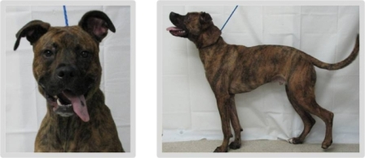 | Dog 08  - 25% Boxer  - 25% Alaskan Malamute  - 21.95% Sealyham Terrier  - 19.67% Pointer | Top Responses  - Boxer  - American Staffordshire Terrier  - Staffordshire Bull Terrier  - Greyhound  - No Predominant Breed
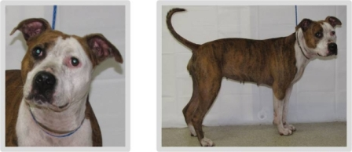 | Dog 09  - 50% American Bulldog  - 50% American Staffordshire Terrier | Top Responses  - American Staffordshire Terrier  - American Bulldog  - Boxer  - Staffordshire Bull Terrier  - Bull Terrier (including miniature)
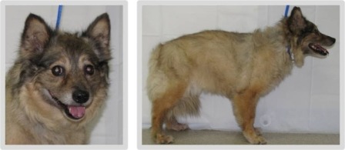 | Dog 10  - 50% American Eskimo  - 25% Beagle  - 25% Labrador Retriever | Top Responses  - Keeshond  - Shetland Sheepdog  - Pomeranian  - German Shepherd Dog  - No Predominant Breed
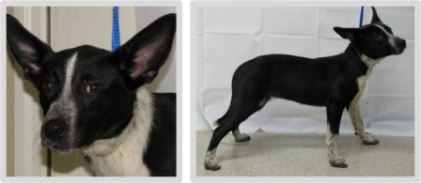 | Dog 11  - 25% Australian Cattle Dog  - 25% American Staffordshire Terrier  - 3.56% Bull Mastiff  - 2.89% Newfoundland | Top Responses  - Australian Cattle Dog  - Border Collie  - Corgi (including Cardigan, Pembroke)  - No Predominant Breed  - Boston Terrier
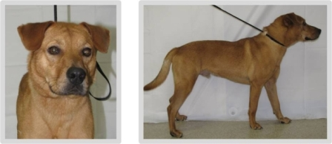 | Dog 12  - 25% Labrador Retriever  - 12.5% Chow Chow  - 12.5% Beagle  - 24.89% Puli | Top Responses  - Labrador Retriever  - Shar-Pei, Chinese  - Chow Chow  - No Predominant Breed  - Rhodesian Ridgeback
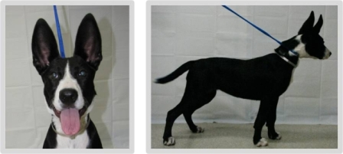 | Dog 13  - 25% German Shepherd  - 25% Staffordshire Bull Terrier  - 13.36% Weimeraner  - 7.29% German Wirehaired Pointer | Top Responses  - Border Collie  - German Shepherd Dog  - Basenji  - Great Dane  - Boston Terrier
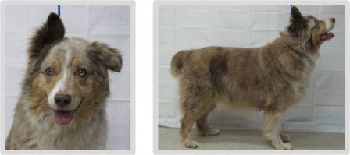 | Dog 14  - 50% Australian Shepherd  - 50% American Eskimo | Top Responses  - Australian Shepherd  - Australian Cattle Dog  - Border Collie  - Anatolian Shepherd Dog  - Collie
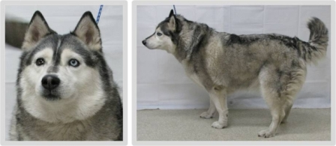 | Dog 15  - 50% Siberian Husky  - 20.35% Chow Chow  - 7.5% Bloodhound  - 4.03% Samoyed | Top Responses  - Siberian Husky  - Malamute, Alaskan  - American Eskimo Dog  - Alaskan Klee Kai  - Akita
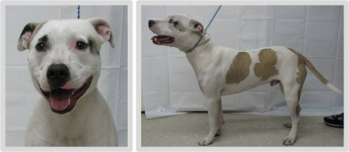 | Dog 16  - 25% American Staffordshire  - 25% Staffordshire Bull Terrier  - 8.83% Flat Coated Retriever  - 3.14% Irish Wolfhound | Top Responses  - American Staffordshire Terrier  - American Bulldog  - Staffordshire Bull Terrier  - Bull Terrier (including miniature)  - No Predominant Breed
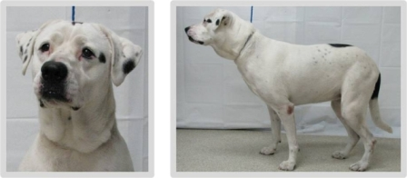 | Dog 17  - 25% Rottweiler  - 12.5% Boxer  - 12.5% German Shorthaired Pointer  - 11.09% Manchester Terrier | Top Responses  - American Bulldog  - Dalmatian  - Labrador Retriever  - Boxer  - American Staffordshire Terrier
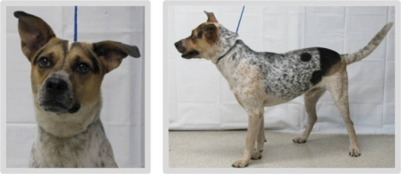 | Dog 18  - 25% Labrador Retriever  - 25% Swedish Vallhund  - 12.5% German Spitz  - 12.5% Weimeraner | Top Responses  - Australian Cattle Dog  - Catahoula Leopard Dog  - Blue Tick Coonhound  - Beagle  - No Predominant Breed
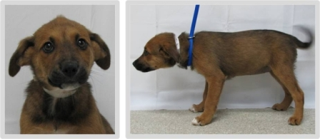 | Dog 20  - 50% American Eskimo  - 25% Cane Corso  - 25% Chinese Sharpei | Top Responses  - German Shepherd Dog  - No Predominant Breed  - Belgian Malinois  - Labrador Retriever  - Beagle
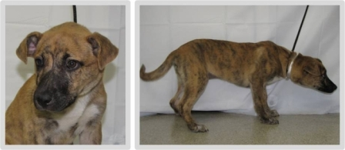 | Dog 22  - 25% Chow Chow  - 12.5% German Shepherd  - 12.5% Alaskan Malamute  - 14.22% Cairn Terrier | Top Responses  - No Predominant Breed  - German Shepherd Dog  - Boxer  - Catahoula Leopard Dog  - American Staffordshire Terrier
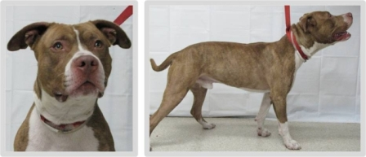 | Dog 23  - 25% American Staffordshire  - 25% Boxer  - 25% Soft Coated Wheaton Terrier  - 18.66% Great Dane | Top Responses  - American Staffordshire Terrier  - Staffordshire Bull Terrier  - American Bulldog  - Bull Terrier (including miniature)  - Boxer
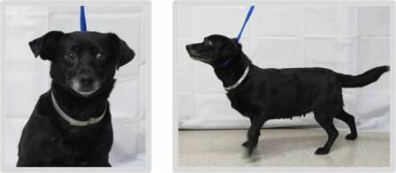 | Dog 24  - 50% Chihuahua  - 25% Keeshond  - 25% Beagle | Top Responses  - Dachshund (including miniature, standard, smooth coat, wirehair, longhair)  - Chihuahua  - No Predominant Breed  - Labrador Retriever  - Corgi (including Cardigan, Pembroke)
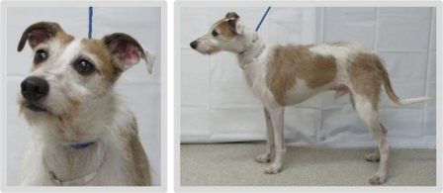 | Dog 25  - 75% Italian Greyhound  - 18.69% Entlebucher Mountain Dog  - 3.9% Bernese Mountain Dog  - 2.24% Rhodesian Ridgeback | Top Responses  - Jack Russell Terrier (includes Russell Terrier)  - Fox Terrier (including smooth, wire, toy)  - Whippet  - Parson Russell Terrier  - Italian Greyhound
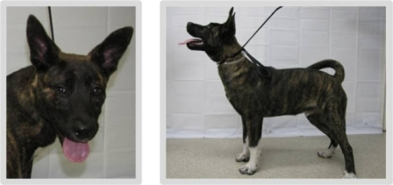 | Dog 26  - 25% German Shepherd  - 25% Chinese Sharpei  - 12.5% Short Haired Dachshund  - 12.65% Dogo Argentino | Top Responses  - Akita  - Basenji  - German Shepherd Dog  - No Predominant Breed  - Australian Cattle Dog
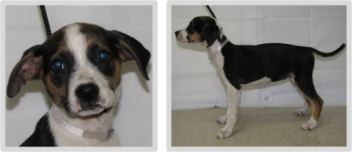 | Dog 28  - 32.5% Boxer  - 25% Weimeraner  - 14.49% Borzoi  - 10.8% Keeshond | Top Responses  - Beagle  - Foxhound (including American, English, Treeing Walker Coonhound)  - No Predominant Breed  - Black and Tan Coonhound  - Jack Russell Terrier (includes Russell Terrier)
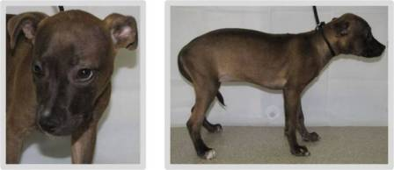 | Dog 29  - 25% American Staffordshire  - 25% Staffordshire Bull Terrier  - 25% Russell Terrier  - 25% Basset Hound | Top Responses  - No Predominant Breed  - American Staffordshire Terrier  - Chihuahua  - Boxer  - Labrador Retriever
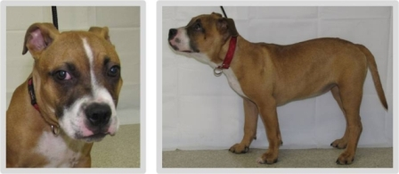 | Dog 30  - 25% American Staffordshire  - 25% French Bulldog  - 12.5% Samoyed  - 11.96% Afghan Hound | Top Responses  - Boxer  - American Staffordshire Terrier  - American Bulldog  - Staffordshire Bull Terrier  - No Predominant Breed
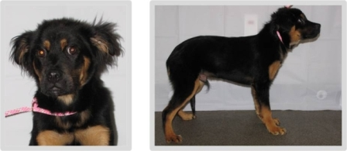 | Dog 31  - 25% Tibetan Mastiff  - 12.5% Boxer  - 15.1% Golden Retriever  - 5.86% Wheaten Terrier | Top Responses  - Rottweiler  - German Shepherd Dog  - No Predominant Breed  - Australian Shepherd  - Cocker Spaniel
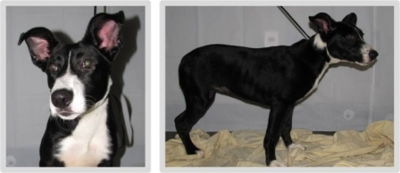 | Dog 33  - 37.5% German Shepherd  - 12.5% Rottweiler  - 12.5% Weimeraner  - 11.44% Irish terrier | Top Responses  - Border Collie  - No Predominant Breed  - Great Dane  - American Staffordshire Terrier  - Boston Terrier
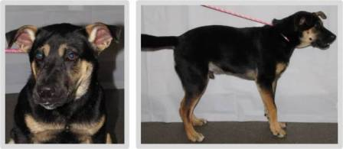 | Dog 35  - 25% Chow Chow  - 12.5% German Shepherd  - 12.5% Boxer  - 9.39% Newfoundland | Top Responses  - German Shepherd Dog  - Rottweiler  - No Predominant Breed  - Dobermann Pinscher  - Black and Tan Coonhound
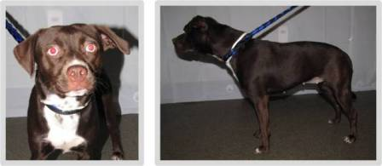 | Dog 36  - 25% Labrador Retriever  - 25% Manchester Terrier  - 25% Belgian Sheepdog  - 12.5% Boston Terrier | Top Responses  - American Staffordshire Terrier  - Labrador Retriever  - No Predominant Breed  - Beagle  - Staffordshire Bull Terrier
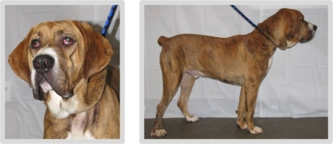 | Dog 37  - 25% Bloodhound  - 25% Boxer  - 10.12% Bull Mastiff  - 7.26% American Foxhound | Top Responses  - Bloodhound  - Mastiff  - Boxer  - Bull Mastiff  - Cane Corso
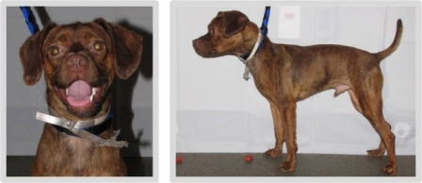 | Dog 38  - 50% Cocker Spaniel  - 25% Boston Terrier  - 25% Miniature Pinscher | Top Responses  - No Predominant Breed  - Boxer  - Pug  - Beagle  - Chihuahua
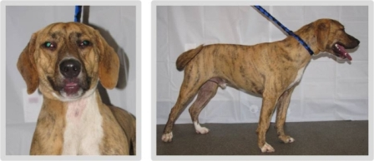 | Dog 39  - 25% American Foxhound  - 25% Bull Mastiff  - 19.89% Scottish Deerhound  - 19.04% Sealyham Terrier | Top Responses  - Plott Hound  - Catahoula Leopard Dog  - Labrador Retriever  - No Predominant Breed  - Boxer
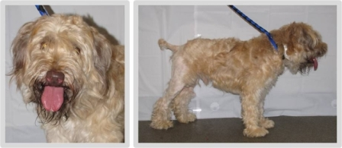 | Dog 40  - 100% Wheaten Terrier | Top Responses  - Wheaten Terrier, Soft Coated  - Poodle (including toy, miniature, standard)  - Bearded Collie  - Cocker Spaniel  - No Predominant Breed
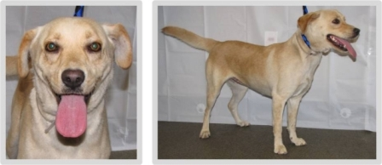 | Dog 41  - 25% Labrador Retriever  - 25% Cane Corso  - 25% Chow Chow  - 25% Miniature Pinscher | Top Responses  - Labrador Retriever  - Golden Retriever  - Beagle  - No Predominant Breed  - Canaan Dog
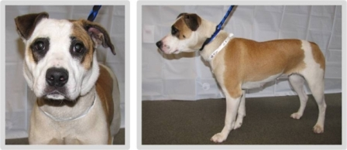 | Dog 42  - 25% Staffordshire Bull Terrier  - 25% Chinese Sharpei  - 25% Havanese  - 6.56% Australian Terrier | Top Responses  - American Staffordshire Terrier  - No Predominant Breed  - American Bulldog  - Boxer  - Bulldog (English)
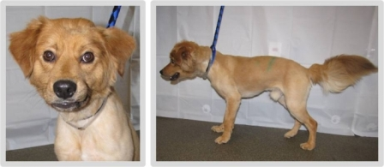 | Dog 43  - 25% Siberian Husky  - 25% American Bulldog  - 11.89% German Spitz  - 5.91% Standard Schnauzer | Top Responses  - Golden Retriever  - Chow Chow  - No Predominant Breed  - Pomeranian  - Nova Scotia Duck Tolling Retriever
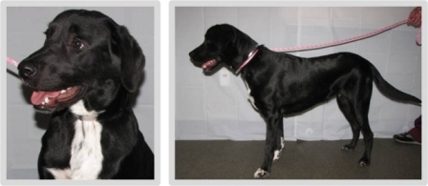 | Dog 44  - 50% Labrador Retriever  - 50% Dalmatian | Top Responses  - Labrador Retriever  - Border Collie  - Flat Coated Retriever  - No Predominant Breed  - Golden Retriever
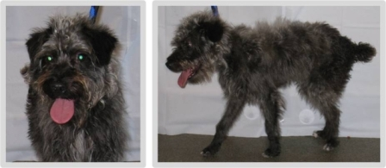 | Dog 46  - 50% Miniature Poodle  - 12.5% Manchester Terrier  - 19.89% Welsh Terrier  - 5.85% Chinese Crested | Top Responses  - Schnauzer (including miniature, standard, giant)  - Cairn Terrier  - Affenpinscher  - Poodle (including toy, miniature, standard)  - No Predominant Breed
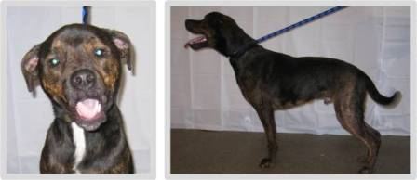 | Dog 47  - 50% American Bulldog  - 25% Rottweiler  - 12.43% Neopolitan Mastiff  - 8.11% Akita | Top Responses  - Rottweiler  - No Predominant Breed  - American Staffordshire Terrier  - Plott Hound  - Labrador Retriever
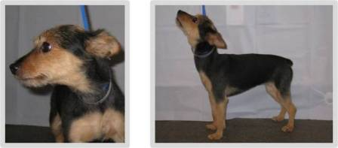 | Dog 48  - 50% Yorkshire Terrier  - 50% Pomeranian | Top Responses  - Yorkshire Terrier  - Miniature Pinscher  - Jack Russell Terrier (includes Russell Terrier)  - Australian Terrier  - No Predominant Breed
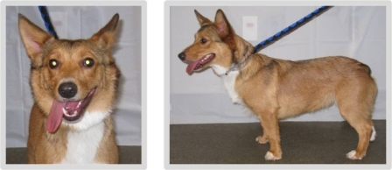 | Dog 49  - 100% Pembroke Welsh Corgi | Top Responses  - Corgi (including Cardigan, Pembroke)  - Swedish Vallhund  - Shetland Sheepdog  - Welsh Terrier  - Basenji
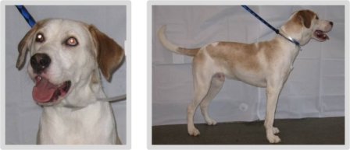 | Dog 51  - 25% Novia Scotia Duck Tolling Retriever  - 25% Irish Water Spaniel  - 25% Fox Terrier  - 12.22% English Springer Spaniel | Top Responses  - Labrador Retriever  - Foxhound (including American, English, Treeing Walker Coonhound)  - Pointer (includes English Pointer)  - Catahoula Leopard Dog  - Beagle
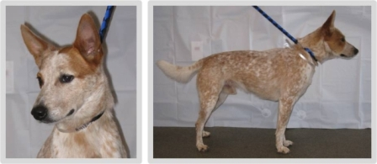 | Dog 52  - 75% Australian Cattle Dog  - 10.26% Lancashire Heeler  - 6.02% Old English Sheepdog  - 5.97% Belgian Malinois | Top Responses  - Australian Cattle Dog  - Australian Kelpie  - Basenji  - Catahoula Leopard Dog  - Australian Shepherd
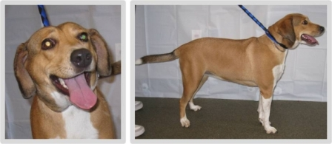 | Dog 53  - 25% Labrador Retriever  - 25% Weimeraner  - 25% Australian Cattle Dog  - 9.65% Beagle | Top Responses  - Beagle  - Foxhound (including American, English, Treeing Walker Coonhound)  - Labrador Retriever  - No Predominant Breed  - Harrier
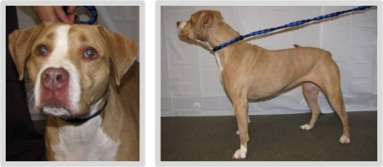 | Dog 54  - 25% Bulldog  - 12.5% Mastiff  - 12.5% Boxer  - 10.42% Tibetan Mastiff | Top Responses  - American Staffordshire Terrier  - Boxer  - American Bulldog  - Staffordshire Bull Terrier  - No Predominant Breed
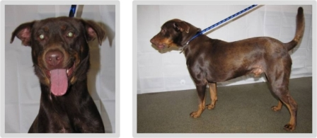 | Dog 55  - 25% Great Dane  - 25% Schipperke  - 12.5% Chow Chow  - 12.5% Collie | Top Responses  - Dobermann Pinscher  - Labrador Retriever  - No Predominant Breed  - Rottweiler  - Dachshund (including miniature, standard, smooth coat, wirehair, longhair)
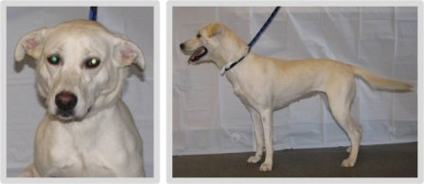 | Dog 57  - 25% Beauceron  - 25% Siberian Husky  - 25% American Staffordshire Terrier  - 12.73% Schipperke | Top Responses  - Labrador Retriever  - German Shepherd Dog  - No Predominant Breed  - Golden Retriever  - Anatolian Shepherd Dog
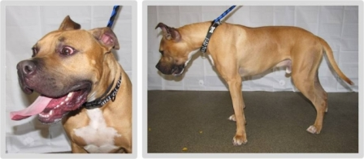 | Dog 58  - 25% Boxer  - 25% Entlebucher Mountain Dog  - 25% German Spitz  - 9.14% Golden Retriever | Top Responses  - Boxer  - Great Dane  - American Staffordshire Terrier  - American Bulldog  - Staffordshire Bull Terrier
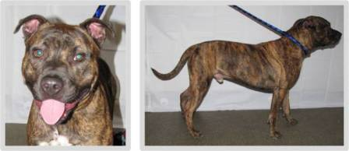 | Dog 59  - 50% American Bulldog  - 50% American Staffordshire Terrier | Top Responses  - American Staffordshire Terrier  - Staffordshire Bull Terrier  - Boxer  - American Bulldog  - Mastiff
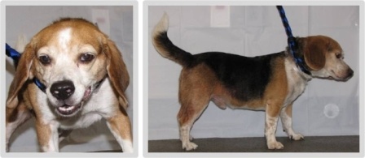 | Dog 60  - 100% Beagle | Top Responses  - Beagle  - Basset Hound  - No Predominant Breed  - Foxhound (including American, English, Treeing Walker Coonhound)  - Pug
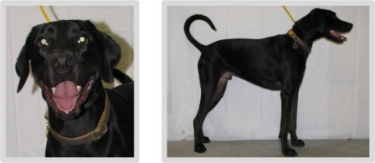 | Dog 61  - 50% Doberman Pinscher  - 25% Labrador Retriever  - 12.5% Bulldog  - 5.83% Irish Water Spaniel | Top Responses  - Labrador Retriever  - Great Dane  - Greyhound  - No Predominant Breed  - Black and Tan Coonhound
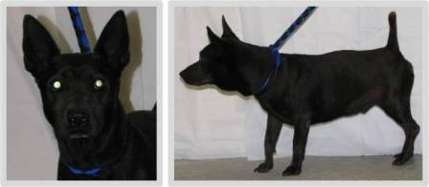 | Dog 62  - 25% Chow Chow  - 25% American Staffordshire Terrier  - 25% Siberian Husky  - 13.71% Australian Terrier | Top Responses  - Schipperke  - No Predominant Breed  - Corgi (including Cardigan, Pembroke)  - Basenji  - Australian Kelpie
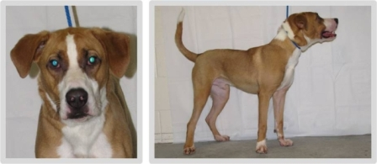 | Dog 63  - 25% Bulldog  - 12.5% Bullmastiff  - 7.35% Basset Hound  - 7.2% Keeshond | Top Responses  - No Predominant Breed  - Boxer  - Foxhound (including American, English, Treeing Walker Coonhound)  - Labrador Retriever  - American Staffordshire Terrier
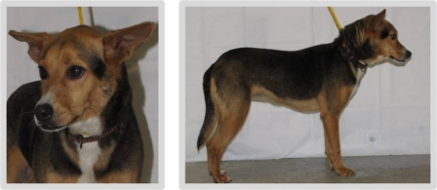 | Dog 64  - 50% Russell Terrier  - 50% Plott Hound | Top Responses  - Beagle  - No Predominant Breed  - German Shepherd Dog  - Corgi (including Cardigan, Pembroke)  - Basenji
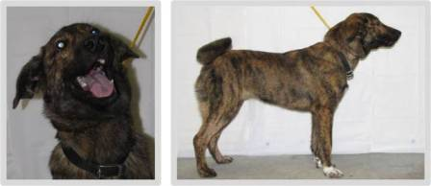 | Dog 65  - 50% Red Bone Coonhound  - 25% German Shepherd  - 12.5% Labrador Retriever  - 10.02% Curly-Coated Retriever | Top Responses  - German Shepherd Dog  - No Predominant Breed  - Akita  - Belgian Malinois  - Australian Shepherd
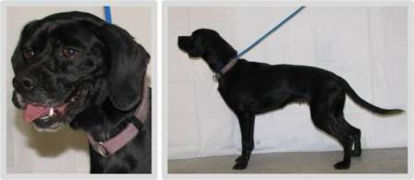 | Dog 66  - 50% Cocker Spaniel  - 25% Pomeranian  - 16.91% Lowchen  - 3.5% Field Spaniel | Top Responses  - Cocker Spaniel  - Labrador Retriever  - Beagle  - No Predominant Breed  - Flat Coated Retriever
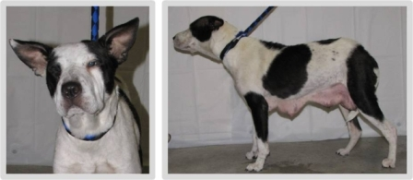 | Dog 67  - 25% American Bulldog  - 25% Staffordshire Bull Terrier  - 10.49% English Cocker Spaniel  - 7.41% Chinese Sharpei | Top Responses  - No Predominant Breed  - Bull Terrier (including miniature)  - Shar-Pei, Chinese  - American Staffordshire Terrier  - Border Collie
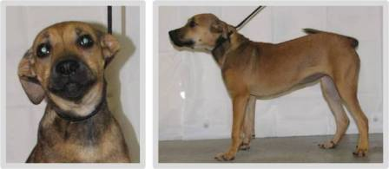 | Dog 68  - 25% American Staffordshire Terrier  - 25% French Bulldog  - 25% American Foxhound  - 22.13% Belgian Tervuren | Top Responses  - German Shepherd Dog  - No Predominant Breed  - Rhodesian Ridgeback  - Anatolian Shepherd Dog  - Belgian Malinois
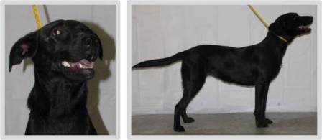 | Dog 69  - 25% Labrador Retriever  - 25% Bulldog  - 25% Australian Cattle Dog  - 13.95% Australian Terrier | Top Responses  - Labrador Retriever  - Flat Coated Retriever  - No Predominant Breed  - Border Collie  - Golden Retriever
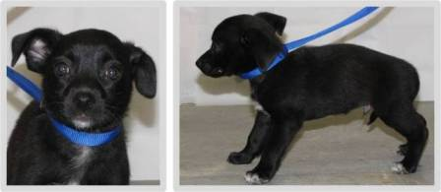 | Dog 71  - 25% Miniature Pinscher  - 25% Brittany Spaniel  - 25% Chinese Crested  - 12.83% German Spitz | Top Responses  - Chihuahua  - No Predominant Breed  - Labrador Retriever  - Border Collie  - Schipperke
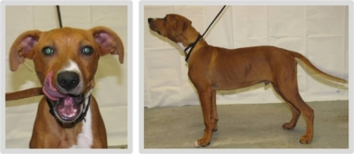 | Dog 72  - 25% American Bulldog  - 25% Portuguese Water Dog  - 25% Saluki  - 1.99% Bichon Frise | Top Responses  - No Predominant Breed  - Vizsla  - Rhodesian Ridgeback  - Redbone Coonhound  - American Staffordshire Terrier
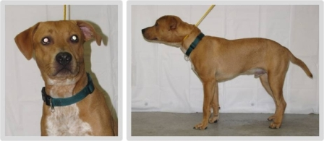 | Dog 73  - 25% American Staffordshire Terrier  - 12.5% Miniature Bull Terrier  - 10.63% Miniature Poodle  - 9.38% American Bulldog | Top Responses  - Labrador Retriever  - No Predominant Breed  - American Staffordshire Terrier  - Rhodesian Ridgeback  - Boxer
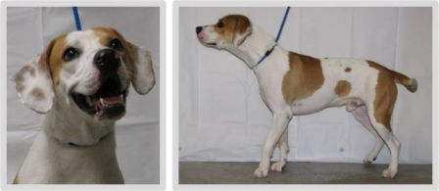 | Dog 74  - 25% Boxer  - 25% Beagle  - 25% English Toy Terrier  - 14.66% Saint Bernard | Top Responses  - Pointer (includes English Pointer)  - Beagle  - Foxhound (including American, English, Treeing Walker Coonhound)  - No Predominant Breed  - Brittany
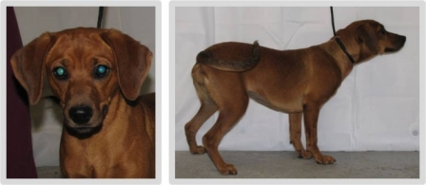 | Dog 76  - 50% Short Haired Dachshund  - 25% Boxer  - 11.51% Silky Terrier  - 5.64% Labrador Retriever | Top Responses  - Dachshund (including miniature, standard, smooth coat, wirehair, longhair)  - Beagle  - No Predominant Breed  - Vizsla  - Redbone Coonhound
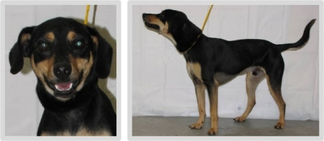 | Dog 77  - 25% Golden Retriever  - 25% Basset Hound  - 11.22% Cairn Terrier  - 10.55% German Shepherd | Top Responses  - Black and Tan Coonhound  - Dobermann Pinscher  - Rottweiler  - No Predominant Breed  - German Shepherd Dog
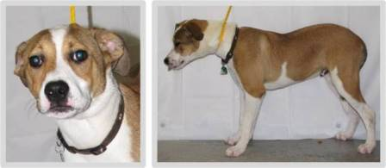 | Dog 79  - 25% Doberman Pinscher  - 25% Wire Haired Dachshund  - 12.5% Samoyed  - 12.5% Miniature Schnauzer | Top Responses  - No Predominant Breed  - American Staffordshire Terrier  - Boxer  - Beagle  - Collie
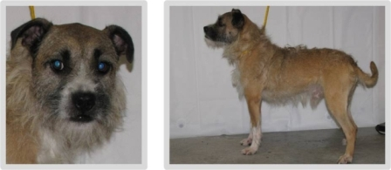 | Dog 81  - 50% Chihuahua  - 9.12% Dogue de Bordeaux  - 8.07% Yorkshire Terrier  - 6.93% Great Pyrenees | Top Responses  - Border Terrier  - Brussels Griffon  - No Predominant Breed  - Jack Russell Terrier (includes Russell Terrier)  - Cairn Terrier
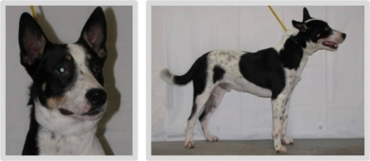 | Dog 82  - 25% Australian Cattle Dog  - 17.15% Miniature Bull Terrier  - 14.98% Scottish Deerhound  - 12.8% Australian Shepherd | Top Responses  - Australian Cattle Dog  - Border Collie  - Australian Kelpie  - No Predominant Breed  - Australian Shepherd
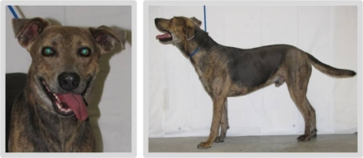 | Dog 83  - 25% Boxer  - 25% Italian Greyhound  - 25% Miniature Short Haired Dachshund  - 8.41% Staffordshire Bull Terrier | Top Responses  - German Shepherd Dog  - No Predominant Breed  - Catahoula Leopard Dog  - Greyhound  - Plott Hound
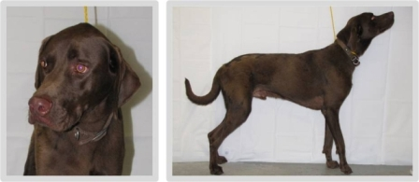 | Dog 84  - 75% Weimeraner  - 25% Labrador Retriever | Top Responses  - Labrador Retriever  - Weimaraner  - German Shorthaired Pointer  - Pointer (includes English Pointer)  - Great Dane
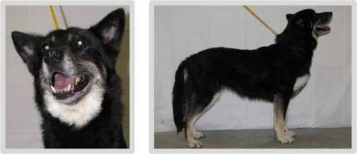 | Dog 85  - 25% Beauceron  - 12.5% German Shepherd  - 12.5% Siberian Husky  - 12.14% Komondor | Top Responses  - German Shepherd Dog  - Siberian Husky  - Malamute, Alaskan  - Australian Shepherd  - Border Collie
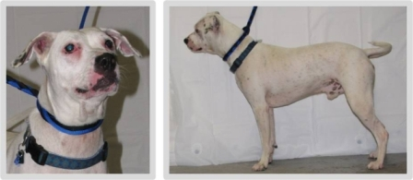 | Dog 88  - 25% Plott Hound  - 25% Boston Terrier  - 25% German Spitz  - 11.68% Saluki | Top Responses  - American Bulldog  - American Staffordshire Terrier  - Boxer  - Dalmatian  - Argentine Dogo
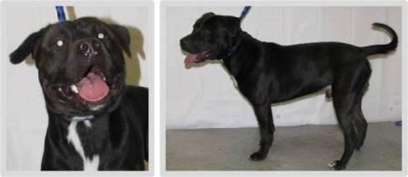 | Dog 89  - 25% Bulldog  - 25% Boxer  - 12.98% Blue Tick Coonhound  - 10.9% Weimeraner | Top Responses  - American Staffordshire Terrier  - Rottweiler  - Staffordshire Bull Terrier  - American Bulldog  - Labrador Retriever
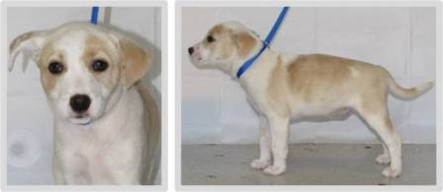 | Dog 92  - 25% Australian Cattle Dog  - 25% Border Collie  - 9.77% Miniature Pinscher  - 9.57% Labrador Retriever | Top Responses  - No Predominant Breed  - Beagle  - Labrador Retriever  - Jack Russell Terrier (includes Russell Terrier)  - Australian Shepherd
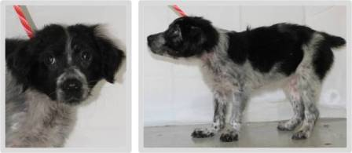 | Dog 93  - 25% Weimeraner  - 8.28% Beagle  - 8.23% Cane Corso  - 4.18% Rottweiler | Top Responses  - Australian Shepherd  - Border Collie  - No Predominant Breed  - Australian Cattle Dog  - Cocker Spaniel
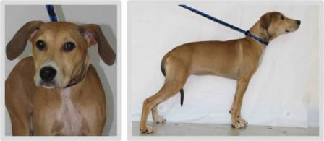 | Dog 94  - 25% Golden Retriever  - 25% Poodle  - 18.98% Dandie Dinmont Terrier  - 10.35% Glen of Imaal Terrier | Top Responses  - No Predominant Breed  - Beagle  - Greyhound  - Foxhound (including American, English, Treeing Walker Coonhound)  - Rhodesian Ridgeback
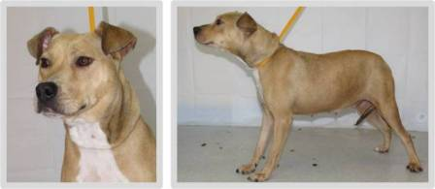 | Dog 95  - 25% American Staffordshire Terrier  - 25% Dogue de Bordeaux  - 3.66% Irish Terrier  - 2.17% Dandie Dinmont Terrier | Top Responses  - American Staffordshire Terrier  - No Predominant Breed  - Staffordshire Bull Terrier  - Labrador Retriever  - Shar-Pei, Chinese
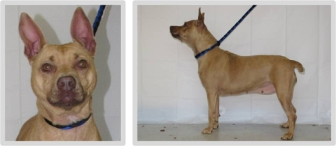 | Dog 96  - 50% American Staffordshire Terrier  - 6.95% Vizsla  - 5.86% Miniature Pinscher  - 0.89% Collie | Top Responses  - American Staffordshire Terrier  - No Predominant Breed  - Staffordshire Bull Terrier  - Basenji  - Miniature Pinscher
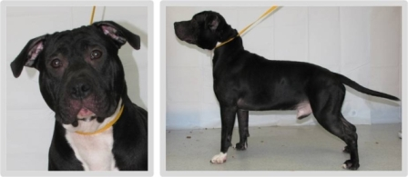 | Dog 97  - 50% American Staffordshire Terrier  - 25% Bullmastiff  - 8.73% Collie  - 2.48% Bulldog | Top Responses  - American Staffordshire Terrier  - Staffordshire Bull Terrier  - American Bulldog  - Shar-Pei, Chinese  - Mastiff
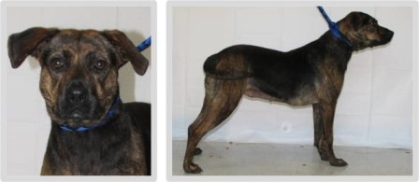 | Dog 98  - 25% Norwegian Elkhound  - 25% Miniature Short Haired Dachshund  - 14.38% Sealyham Terrier  - 10.35% Dogue de Bordeaux | Top Responses  - No Predominant Breed  - German Shepherd Dog  - Plott Hound  - Black and Tan Coonhound  - American Staffordshire Terrier
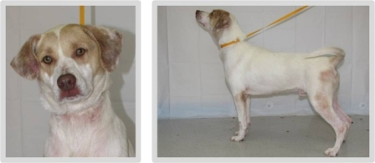 | Dog 99  - 25% American Staffordshire Terrier  - 25% Collie  - 21.41% Black Russian Terrier  - 19.86% Norwegian Buhund | Top Responses  - Labrador Retriever  - No Predominant Breed  - Pointer (includes English Pointer)  - Brittany  - Foxhound (including American, English, Treeing Walker Coonhound)
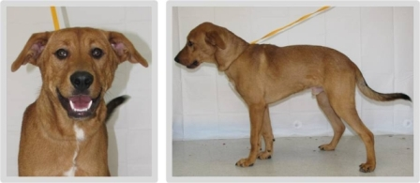 | Dog 100  - 25% Rottweiler  - 25% American Eskimo  - 25% Portuguese Water Dog  - 15.23% Bulldog | Top Responses  - Labrador Retriever  - No Predominant Breed  - German Shepherd Dog  - Rhodesian Ridgeback  - Golden Retriever
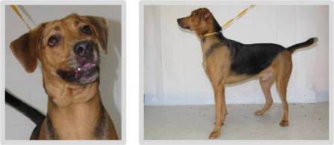 | Dog 101  - 25% Curly Coated Retriever  - 25% Jindo  - 13.31% Norfolk Terrier  - 11.43% Russell Terrier | Top Responses  - Black and Tan Coonhound  - German Shepherd Dog  - Bloodhound  - No Predominant Breed  - Foxhound (including American, English, Treeing Walker Coonhound)
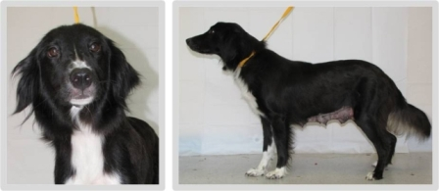 | Dog 102  - 50% Golden Retriever  - 25% Flat Coated Retriever  - 16.24% German Spitz  - 9.8-% Norfolk Terrier | Top Responses  - Border Collie  - Saluki  - Flat Coated Retriever  - Afghan Hound  - Springer Spaniel (including English, Welsh)
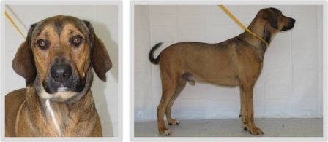 | Dog 103  - 25% Labrador Retriever  - 25% Tibetan Mastiff  - 13.96% American Eskimo  - 11.45% Long Haired Dachshund | Top Responses  - Bloodhound  - Black and Tan Coonhound  - Rhodesian Ridgeback  - No Predominant Breed  - German Shepherd Dog
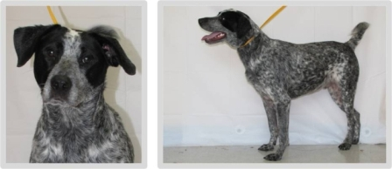 | Dog 104  - 25% Australian Cattle Dog  - 25% Labrador Retriever  - 25% Jindo  - 17.69% Great Dane | Top Responses  - Australian Cattle Dog  - German Shorthaired Pointer  - Pointer (includes English Pointer)  - Blue Tick Coonhound  - English Setter
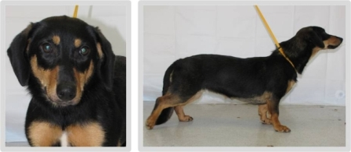 | Dog 106  - 25% Miniature Short Haired Dachshund  - 25% Siberian Husky  - 20.11% Black and Tan Coonhound  - 12.73% Irish Setter | Top Responses  - Dachshund (including miniature, standard, smooth coat, wirehair, longhair)  - Basset Hound  - Corgi (including Cardigan, Pembroke)  - No Predominant Breed  - German Shepherd Dog
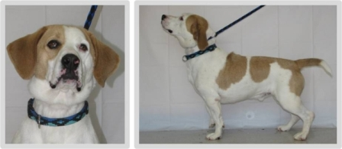 | Dog 107  - 50% Basset Hound  - 25% French Bulldog  - 16.62% Cane Corso  - 10.45% Wire Fox Terrier | Top Responses  - Basset Hound  - Beagle  - Clumber Spaniel  - No Predominant Breed  - Foxhound (including American, English, Treeing Walker Coonhound)
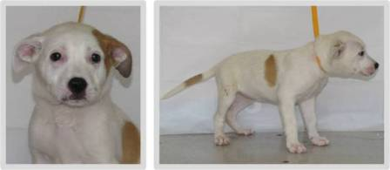 | Dog 108  - 25% American Staffordshire Terrier  - 25% Shetland Sheepdog  - 25% Yorkshire Terrier  - 10.8% Manchester Terrier | Top Responses  - No Predominant Breed  - American Staffordshire Terrier  - Labrador Retriever  - American Bulldog  - Jack Russell Terrier (includes Russell Terrier)
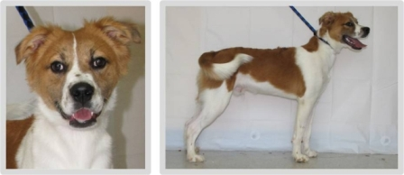 | Dog 109  - 25% Beauceron  - 25% Boxer  - 15.03% Ibizian Hound  - 12.96% Chinese Crested | Top Responses  - Brittany  - No Predominant Breed  - Springer Spaniel (including English, Welsh)  - Border Collie  - Australian Shepherd
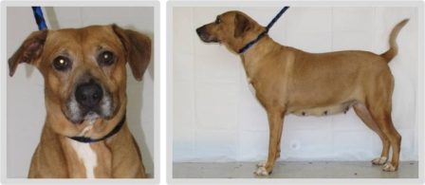 | Dog 110  - 50% Staffordshire Bull Terrier  - 25% Collie  - 25% Small Munsterlander | Top Responses  - Labrador Retriever  - No Predominant Breed  - Rhodesian Ridgeback  - Boxer  - German Shepherd Dog
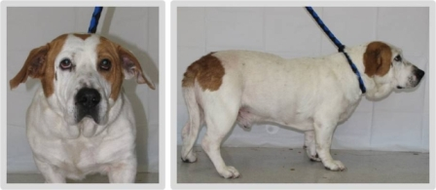 | Dog 111  - 25% Basset Hound  - 25% American Staffordshire Terrier  - 25% Chow Chow  - 25% English Cocker Spaniel | Top Responses  - Basset Hound  - Clumber Spaniel  - Bulldog (English)  - No Predominant Breed  - Beagle
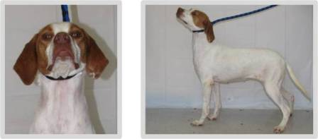 | Dog 112  - 25% German Short Haired Pointer  - 25% Labrador Retriever  - 12.5% Miniature Poodle  - 11.06% Pointer | Top Responses  - Pointer (includes English Pointer)  - Brittany  - Foxhound (including American, English, Treeing Walker Coonhound)  - German Shorthaired Pointer  - Beagle
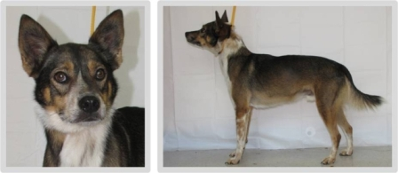 | Dog 114  - 25% Chow Chow  - 25% Puli  - 25% Bull Terrier  - 25% Miniature Schnauzer | Top Responses  - No Predominant Breed  - Australian Cattle Dog  - Australian Kelpie  - Collie  - Basenji
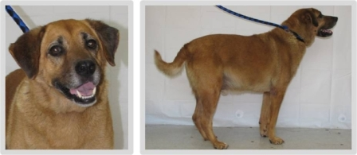 | Dog 115  - 25% Chow Chow  - 25% American Foxhound  - 25% Shetland Sheepdog  - 25% Miniature Poodle | Top Responses  - German Shepherd Dog  - Golden Retriever  - No Predominant Breed  - Labrador Retriever  - Anatolian Shepherd Dog
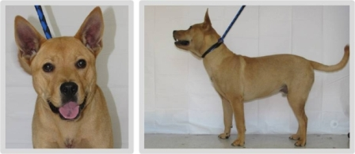 | Dog 116  - 25% Chow Chow  - 25% Catahoula Leopard Dog  - 25% Dalmatian  - 25% Scottish Terrier | Top Responses  - No Predominant Breed  - Chow Chow  - Basenji  - American Staffordshire Terrier  - Akita
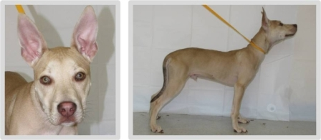 | Dog 117  - 50% American Bulldog  - 25% American Staffordshire Terrier  - 9.28% Pembroke Welsh Corgi  - 7.97% Irish Wolfhound | Top Responses  - Pharaoh Hound  - Ibizan Hound  - No Predominant Breed  - Basenji  - Great Dane
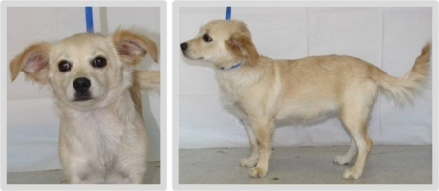 | Dog 119  - 25% English Cocker Spaniel  - 25% Belgian Sheepdog  - 11.35% Chow Chow  - 10.32% Puli | Top Responses  - Chihuahua  - Papillon  - No Predominant Breed  - Pomeranian  - Cocker Spaniel

