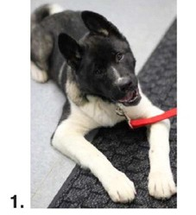 | 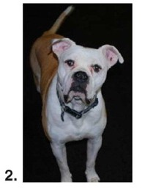 | 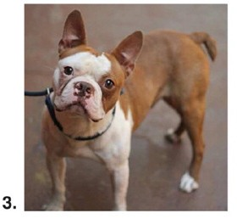
UK 0 – 0% - Akita  US 5 – 1.2% - Akita | UK 1 – 1.9% - American Bulldog  US 74 – 17.8% - American Bulldog | UK 0 – 0% - French Bulldog  US 5 – 1.2% - Boston Terrier
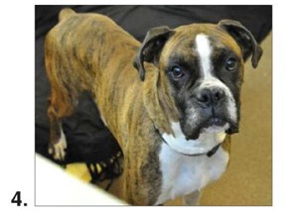 | 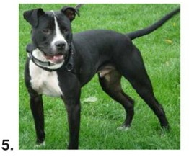 | 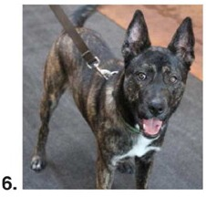
UK 0 – 0% - Boxer  US 6 – 1.4% - Boxer | UK 11 – 20.4% - Staffordshire Bull Terrier  US 334 – 50.3% - Pit Bull | UK 0 – 0% - German Shepherd  US 25 – 6.0% - Shepherd

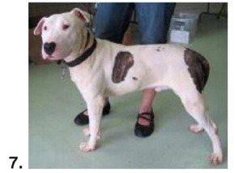 | 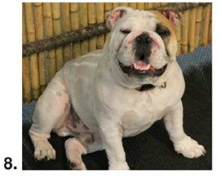 | 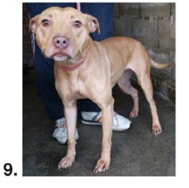
UK 7 – 13.0% - Bull Terrier  US 63 – 39.2% - Bull Terrier | UK 0 – 0% - English Bulldog  US 6 – 1.4% - English Bulldog | UK 21 – 38.9% - Staffordshire Bull Terrier  US 349 – 83.9% - Staffordshire Bull Terrier

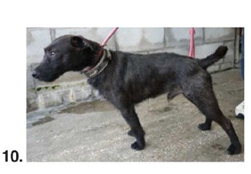 | 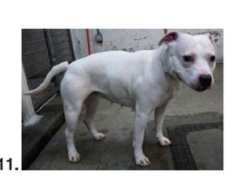 | 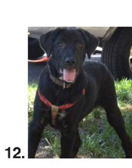
UK 0 – 0% - Patterdale  US 3 – 0.7% - Terrier | UK 1 – 0% - Staffordshire Bull Terrier  US 294 – 70.7% - Pit Bull | UK 0 – 0% - Labrador  US 2 – 0.5% - Labrador

 | 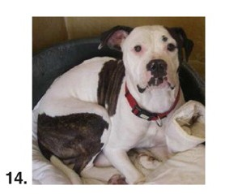 | 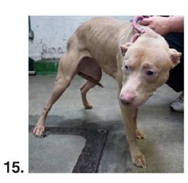
UK 0 – 0% - Mix  US 41 – 9.9% - Shepherd | UK 4 – 7.4% - American Bulldog  US 203 – 48.8% - American Bulldog | UK 32 – 59.3% - “Pit Bull”  US 354 – 85.1% - Pit Bull

N

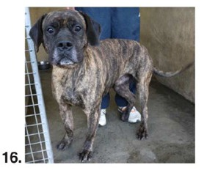 | 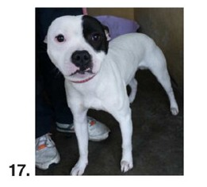 | 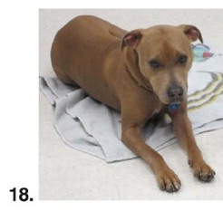
UK 0 – 0% - Mastiff  US 33 – 7.9% - Mastiff | UK 5 – 9.3% - Staffordshire Bull Terrier  US 341 – 82.0% - Pit Bull | UK 14 – 26.0% - Staffordshire Bull Terrier  US 273 – 65.6% - Pit Bull

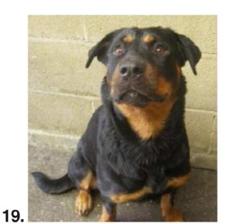 | 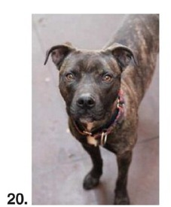
UK 0 – 0% - Rottweiler  US 2 – 0.5% - Rottweiler | UK 10 – 18.5% = Staffordshire Bull Terrier  US 373 – 90.0% - Pit Bull

