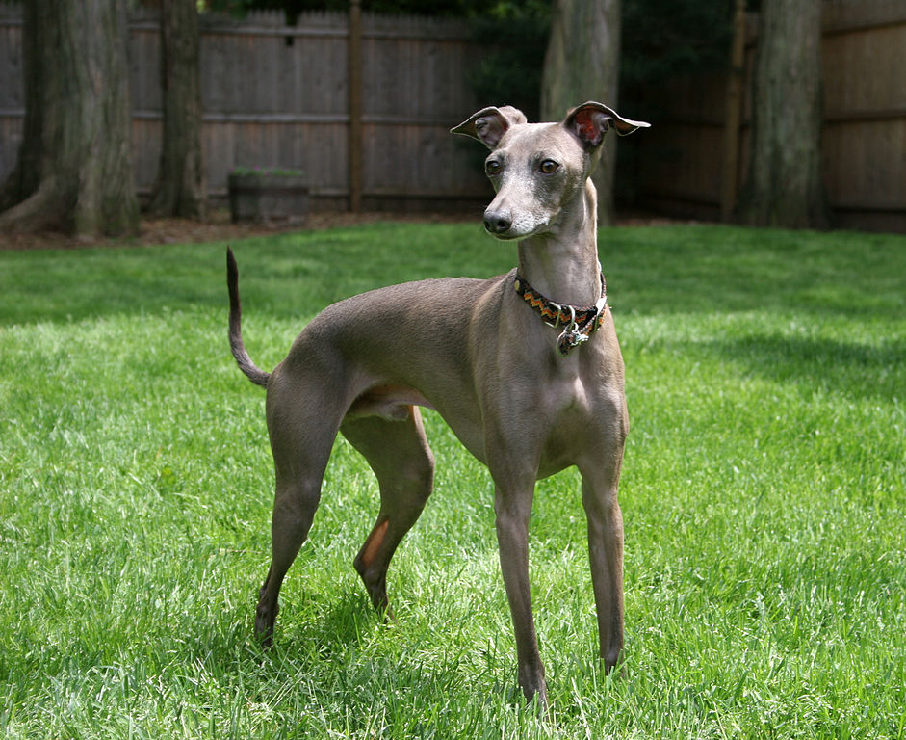 | 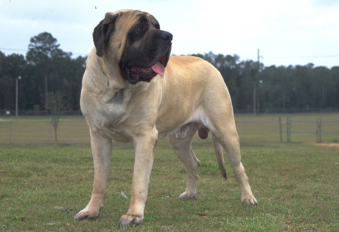
Greyhound  It is believed that they were introduced to the area now known as the United Kingdom in the 5th and 6th century from Celtic mainland Europe. Greyhound-type dogs of small, medium and large size appear to have been bred across Europe since that time.  (Modern Greyhound Male - 60 to 88 pounds) | Mastiff  The English Mastiff was founded in Britain. A very old breed, it was depicted in Egyptian monuments as early as 3000 BC.  (Modern Mastiff Male - 150 to 250 pounds)

Greyhound and Mastiff = Olde English Bulldogge

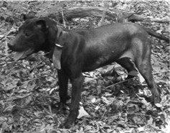 | 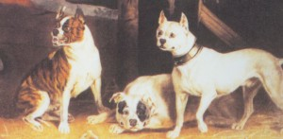
Olde English Terrier  The term "Old English Terrier" has been applied, in the past and present, to the Patterdale Terrier, Black and Tan Terrier and the Manchester Terrier to some degree or another. The Patterdale and Black and Tan Terriers are not recognized “breeds”. The Manchester Terrier is a recognized breed by the universally recognized and accepted kennel clubs. | Olde English Bulldogge (EXTINCT)  (Mastiff crossed with Greyhound)  A cross between the Old English Bulldogge and Old English Terrier created a superior fighting dog with increased quickness and dexterity. None of these “breeds” are recognized by the universally recognized and accepted kennel clubs.

Olde English Terrier and Olde English Bulldogge = One of the dogs called “Pit Bulls”

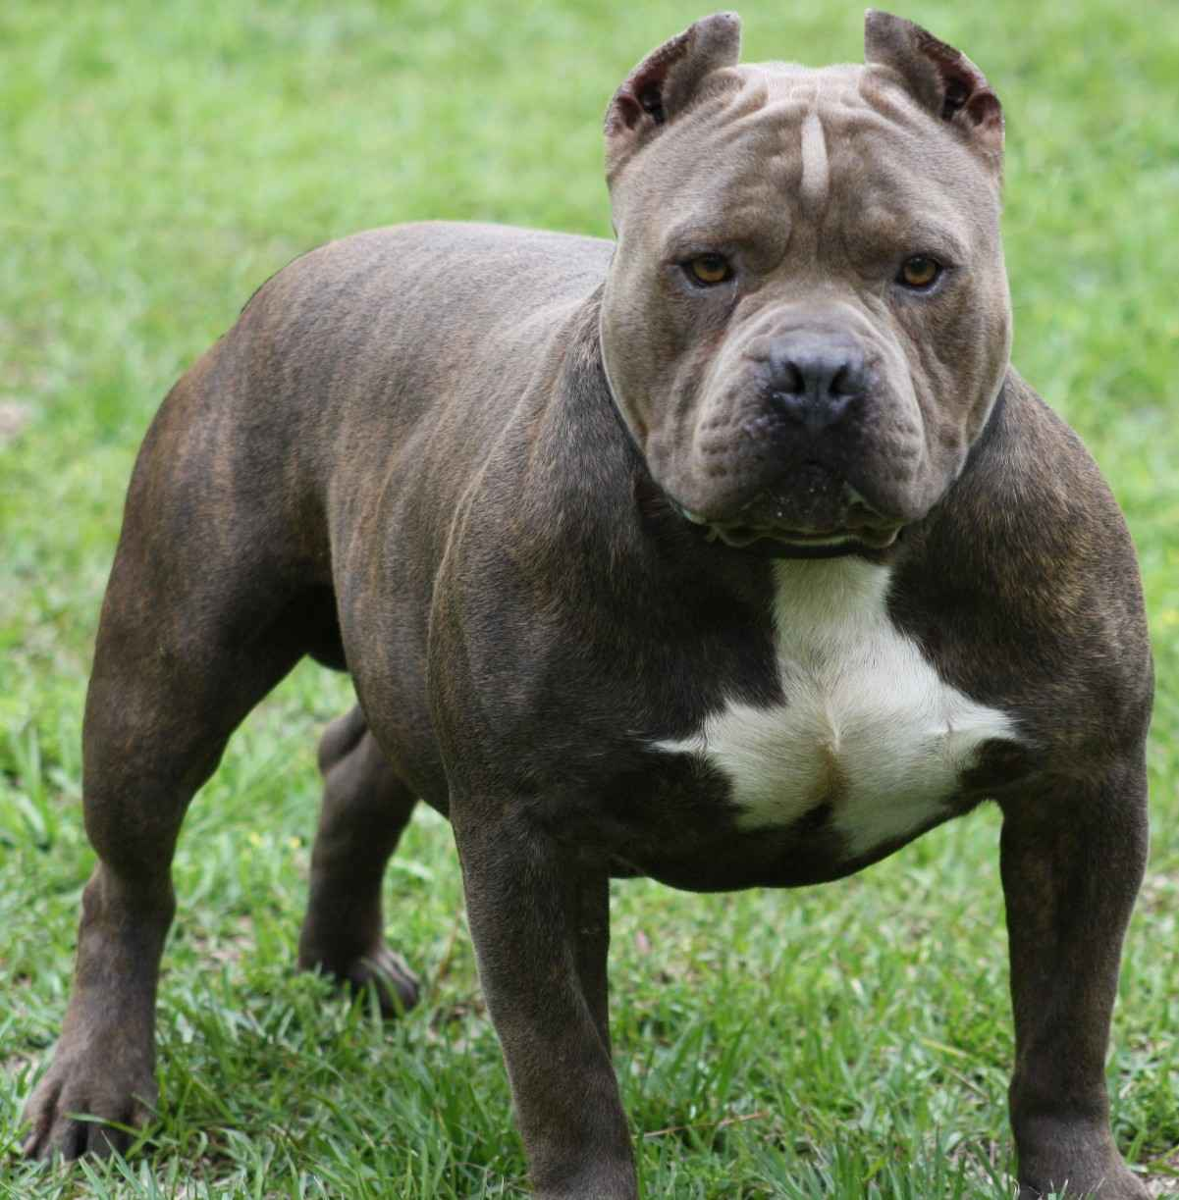
“Pit Bull”
A cross between the Olde English Bulldogge and Olde English Terrier created a superior fighting dog with increased quickness and dexterity.
(Males Typicall – 28 to 38 pounds)

