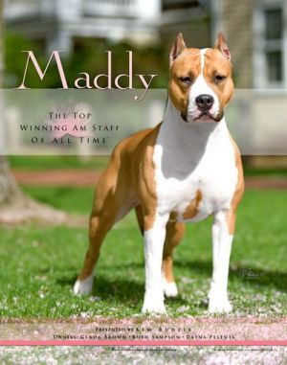 | 24 Best In Show  2009 Best Of Breed -National Specialty – Long Beach, California  2010 Best Of Breed - National Dog Show – Philadelphia, Pennsylvania  2010 Best Of Breed - Westminster Kennel Club  2010 Morris & Essex Kennel Best Terrier Show  2011 Best of Breed -Westminster Kennel Club

