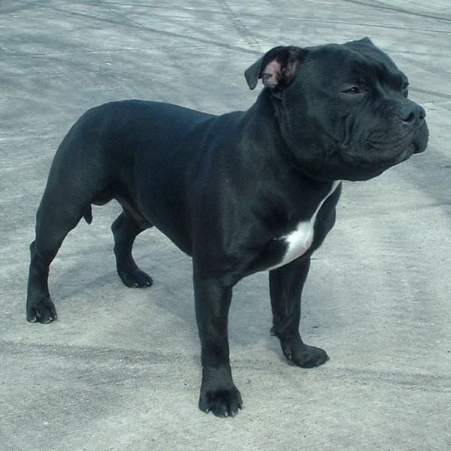 |  | 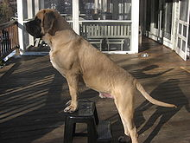 | 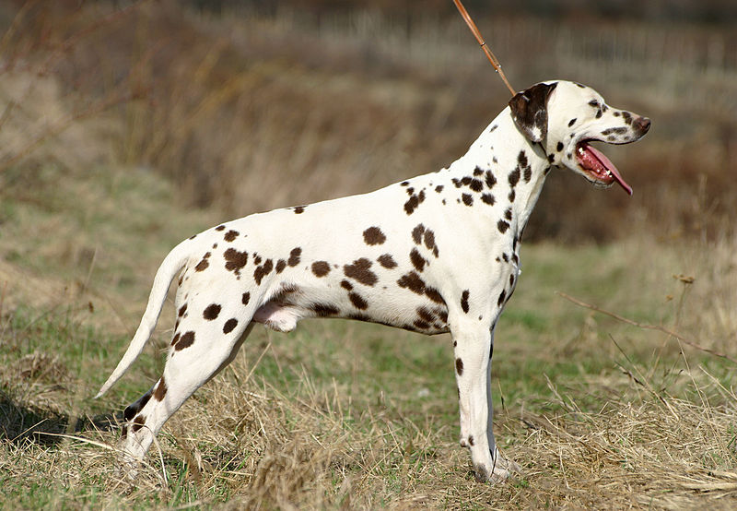
Staffordshire Bull Terrier  Males  28 to 38 pounds | Mastiff  Males  150 to 250 pounds |  |  | Dalmatian  Males  34 to 53 pounds

