 | 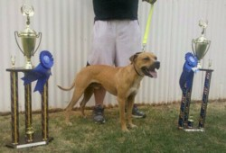 | 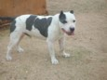
From the American Dog Breeders Association website | From the American  Dog Breeders Association  website | From the American  Dog Breeders  Association website  [Looks like an American Staffordshire Terrier]
http://www.adbadog.com/p_gallary.asp?aid=15&pid=1060 | p://www.adbadog.com/p_gallary.asp?aid=15&pid=1060 | http://www.adbadog.com/p_gallary.asp?aid=15&pid=1060
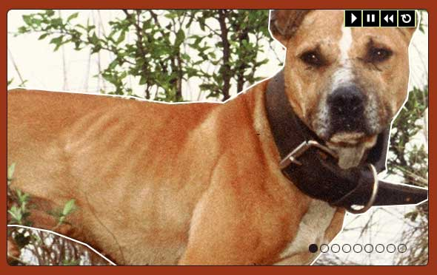

According to the American Dog Breeders Association,
all of the preceding photographs are of American Pit Bull Terriers (“APBT”). Note that from the creation of the breed through 2015, the ADBA registered American Staffordshire Terriers as an APBT. In May 2015, the ADBA acknowledged that the American Staffordshire Terrier was a separate breed. American Pit Bull Terriers are not a breed recognized by the American Kennel Club and all universally recognized and accepted international kennel clubs.

