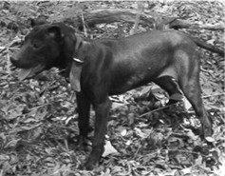 | 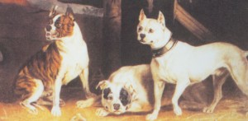
Manchester Terrier | Olde English Bulldogge (EXTINCT)

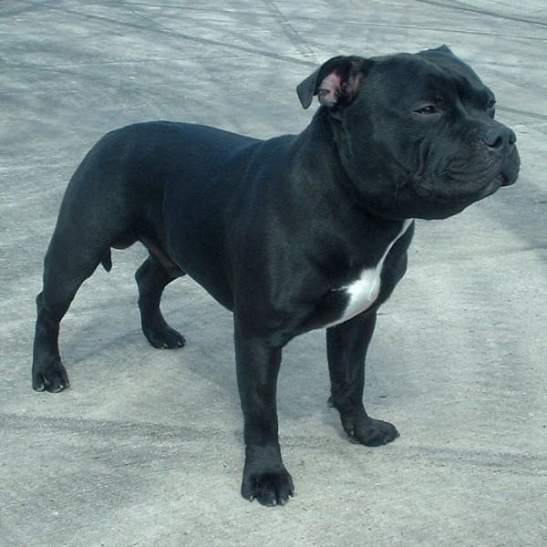

Staffordshire Bull Terrier – A breed recognized by the American Kennel Club and all universally recognized and accepted international kennel clubs.

